Done by: Hashmaryne van Cuylenburg

3D Snake Game Design Document

CO1301: Games Concepts- Assignment

# Overview

3D snake is a recreation of the popular video game concept “Snake”. This game will be developed using the C++ programming language and the gaming engine; TL engine. This will be a desktop game.

Snake is a common video game concept where the objective is to feed a snake with food particles which are found in random positions. The snake grows in length as it eats the food particles. The goal is to eat as much food particles possible while avoiding the snake from colliding with itself or other obstacles (example, the boundaries).

This game is addictive because it keeps the player in a flow; it’s not too hard and not too easy either, making it just the right amount of fun. Moreover, this game can be played by anyone no matter the age since it can keep the player occupied for hours without them getting bored.

A picture containing object, clock

Description generated with very high confidence

*Figure 1: Basic 2D version of snake*

# Gameplay

This version of snake in oppose to most versions of the game, has a 3D interface. In this version, the snake will have to eat apples. The apples are positioned randomly and every time the snake eats an apple, the snake will grow in length and 10 points will be added to the total score. Once the player has eaten 5 apples, a bonus fruit will appear and if the player eats it, 20 points will be added to the total score. Throughout the game, mushrooms will appear too and if the snake eats it, 10 points will be deducted from the total score. If the snake collides with itself or an obstacle (boundary walls, rocks, trees) the game will be over.

There will be three levels of difficulty,

1. Easy
2. Medium
3. Hard

As the level of difficulty increases, the speed of the snake will increase, making it harder to control the snake.

# Graphics

This game will have a fixed camera view which contains a landscape representing a garden and the snake which will be moved around by the player to eat the food particles. There will also be rocks and trees which will act as obstacles. On the top left side of the screen, the score will be displayed. Below is an example on how the game will look. ***Note:- This is not the exact way the game looks as it has not yet been developed, it is only an example on how the structure is going to look like.***

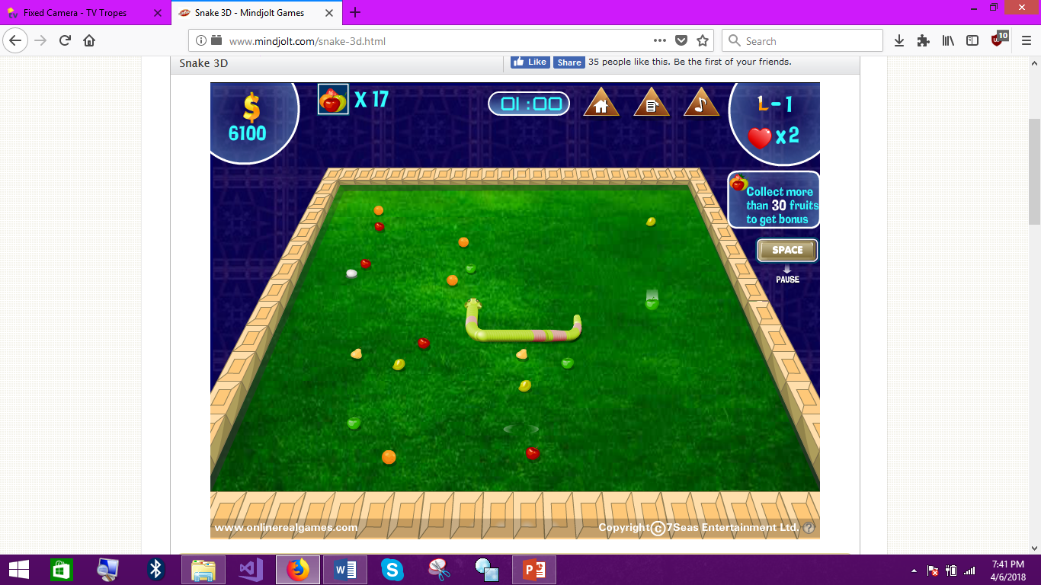

*Figure 2: Example on how the game is going to look like. This game can be found on http://www.mindjolt.com*

# Sound

In the background of the game, a very vibrant and enthusiastic music will be played. Every time the snake eats a food particle, a crunch sound will be played. Moreover, when the snake hits itself or an obstacle a crash sound will be played. If a player gets a high score, a cheerful sound will be played.

# Controls

|  |  |
| --- | --- |
| W A S D keys  A close up of a sign  Description generated with high confidence  Or  Arrow keys | **Movement**   * W or up arrow key to move forward. * A or left arrow key to move left * S or down arrow key to move back. * D or left arrow key to move right. |
| Spacebar | **Pause/Resume game** |
| Esc key  A close up of a camera  Description generated with high confidence | **Exit game** |
| C key  A black sign with white text  Description generated with high confidence | **Change skin of the snake** |

# Game flow structure

Following is the flow of the game,

1. Player starts the game and the welcome screen is displayed.
2. Player is prompted to choose between the 3 difficulty levels.
3. Player enters the game.
4. Game will be played until the player collides with the snake or another obstacle.
5. Game over screen is displayed along with the score. If the score is a high score, the game over screen will indicate that it is a high score.
6. The score leaderboard will be displayed.
7. Player will be given the option to play again, go back to the menu or exit the game.